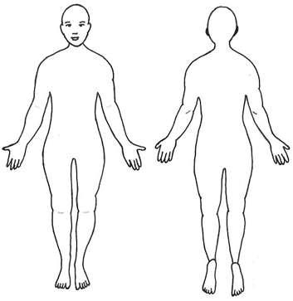

Client Registration Form:

**Name:**

**Date:**

**Address:**

**Cellular Phone:**

**Does this phone accept text messages?:**

**Email Address:**

**Yes**

**No**

**How did you first hear about Utrecht Ayurveda?**

**Age:**

**Place of Birth:**

**Date of Birth:**

**Height:**

**Transgender/Other**

**Gender:**

**Male**

**Female**

**Weight:**

**Occupation:**

**Are You Pregnant?:**

**Yes**

**No**

**If Yes, What Trimester?:**

**Family Medical History:**

**Current Symptoms:**

**Light**

**Yes**

**Do Experience Difficulty Falling Asleep?**

**No**

**No**

**Type And Amount________________________**

**Do You Suffer From Sleep Continuity Disturbance?**

**Sleep:**

**Salt Intake:**

**How Long Have You Been Experiencing These Symptoms?:**

**Yes**

**Yes**

**Light**

**(Waking Throughout The Night)**

**Moderate**

**Moderate**

**Heavy**

**Alcohol:**

**Heavy**

**Caffeine Intake:**

**Type And Amount__________________**

**Are You Tired Or Drowsy In The Daytime?**

**Habits:**

**Light**

**Are You Alert Or Tired Upon Waking In The Morning?**

**Moderate**

**Heavy**

**Fat Intake:**

**Smoking:**

**No**

**Alert**

**Tired**

**If Yes, What Are You Taking?_________________**

**Describe Your Exercise Routine:**

**No**

**If Yes, What Are You Taking?_________________**

**Yes**

**Are You Taking Any Herbal Supplements?**

**Are You Taking Any Herbal Supplements?**

**No**

**Yes**

**Personal Medical History including any Surgeries:**

**CANCELLATION POLICY: FULL PAYMENT IS DUE IF YOU CANCEL YOUR SESSION WITHIN 48 HOURS OF YOUR APPOINTMENT.**

**Name of Health Insurance provider?**

**Are You Willing To Take Herbal Supplements If Recommended**

**By The Ayurvedic Practitioner After The Consultation?**

**Yes**

**No**

**Indicate with a circle where you are experiencing body pain.**

**Does your health insurance policy cover complementary Healthcare?:**

**No**

**Yes**